6 pins Harley keySwitch and wiring

TOP OF THE SWITCH

White Grey
Brown
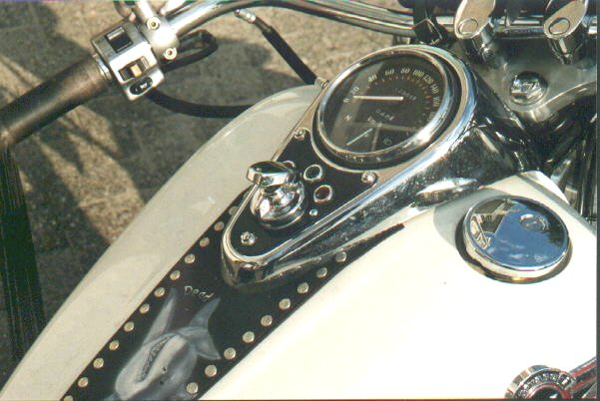
From the original wiring connect the blue and red together (wiring of the lights)
Into the grey wire put a restistor 100 ohm 1 watt

The wiringdiagram can be something different with the US models and the Europeanmodels

